**CODE:**

library(data.table)

item_data <- data.table(item_id=c(101,102,103,104),

item_name=c('Fridge','TV','AC','OVEN'),

item_qty=c(35,45,23,18),

item_price=c(18000,24000,40000,10000)

)

x=subset(item_data,item_qty>40)

print(x)

**OUTPUT:**

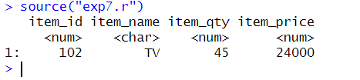

**CODE:**

library(data.table)

item_data <- data.table(item_id=c(101,102,103,104),

item_name=c('Fridge','TV','AC','AC'),

item_qty=c(35,45,23,18),

item_price=c(18000,24000,40000,30000)

)

x=item_data[,mean(item_price),by=item_name]

print(x)

**OUTPUT:**

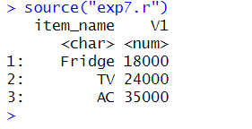

**CODE:**

library(data.table)

item_data1 <- data.table(item_id=c(101,102,103,104),

item_name=c('Fridge','TV','AC','Oven'),

item_qty=c(35,45,23,18),

item_price=c(18000,24000,40000,30000)

)

item_data2 <- data.table(item_name=c('Fridge','TV','AC','Oven'),

item_ratings=c(3,4,5,4.5))

x=item_data1[item_data2,on="item_name"]

print(x)

**OUTPUT:**

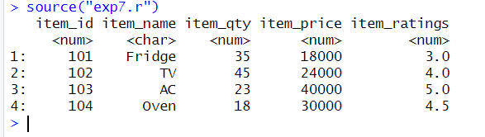

**CODE:**

library(data.table)

item_data1 <- data.table(item_id=c(101,102,103,104),

item_name=c('Fridge','TV','AC','Oven'),

item_qty=c(35,45,23,18),

item_price=c(18000,24000,40000,30000))

x=item_data1[,total_cost:=item_qty*item_price]

print(x)

**OUTPUT:**

